CSCI 4661

Dr. Ben Samuel

Ivan Zelenkov (idzelenk@uno.edu)

September 2, 2022

Problem Analysis and Project Proposal

I want to develop an app related to cryptocurrencies and include many different features that will help my app to compete with other crypto applications. From the start of this semester, I was very motivated by this idea and wanted to start learning React Native as soon as possible.

The app will be called Apex, and I will include some screenshots of the crypto page I already created. The application will help users to do different calculations with cryptocurrencies, understand how much they are going to mine within a timeline, keep them up to date with the latest news and statistics, and more.

Main features that Apex will include:

1. Live ***crypto*** market tracking including animated diagrams that will display statistics within 1 hour, 1 day, 1 week, 1 month, and 1 year. Also, I would like to add the ***NFT*** browser and ***stocks*** market page.
2. Be able to ***save specific crypto*** in a favorite list, so users can track only them.
3. ***Converter*** that will convert any crypto, for example, Bitcoin (BTC) to any currency like the US dollar (USD).
4. ***News*** ***page*** will contain videos and articles.
5. User will have to create an account to get access to other specific features that can be accessed by registered users and be able to get a ***PRO subscription***.
6. ***Mining calculator (Profitability Calculator)*** that will gather different data, for example, what GPU does user have. (This feature can be included in a PRO subscription).
7. ***Beautifully looking UI*** that will have light and dark modes.
8. Users will be able to ***communicate*** with each other.

If I will have more time, then surely there will be more features, for example, a QR code scanner, so users can simply scan the QR code to store blockchain-protected information directly in-app and allow users to trade it.

While researching crypto apps on the App Store, I found that there are many good apps related to this topic, but most of them acted as crypto wallets where users can trade. So, mostly what they provide is the ability to trade crypto and keep users up to date about cryptocurrencies. I was looking for another kind of crypto app that would act like a helper app with cryptocurrencies. I could not find many reviews about those apps, but I am already seeing what should be improved to expand in that area.

I realized that I could improve existing features, add more, and present them all in a single application. And that can be something like a crypto social network, where users can not only observe statistics, but also read the news that includes videos, do calculations related to coins, communicate with each other, and work with mining which I found only in several apps. In an application where diagrams are one of the main elements, they should be drawn as quickly and correctly as possible, without any glitches. As reviews show, problems with displaying and updating the diagram can lead to a very rapid increase in user dissatisfaction and lower ratings, therefore I will follow user reviews and articles on the Internet to make a product better.

I want to make a unified application and see how it will work. I am not sure that I can implement the trading cryptocurrencies feature this semester, but it can be a good improvement for the future.

I discovered different apps from App Store like CryptoDaily, LiveCrypto, Profimine, and Tokeo, and will go over each of them.

1. ***CryptoDaily*** and ***LiveCrypto*** applications contain only several pages. One shows news and another page just crypto market without any animated diagrams. There are a lot of apps like these that have very few features and I think that I surely can create a better app with more features that were listed above.

1. ***Profimine***. This app has included a page that lets users know what revenue will be from mining cryptocurrency. I think that this can be greatly improved by researching more data.

1. ***Tokeo*** is one of the good apps I found, it is looking much better than others, with a little bit more features, but I feel that it does not provide enough for the user. I want Apex to have much more features to engage users in the app as much as possible.

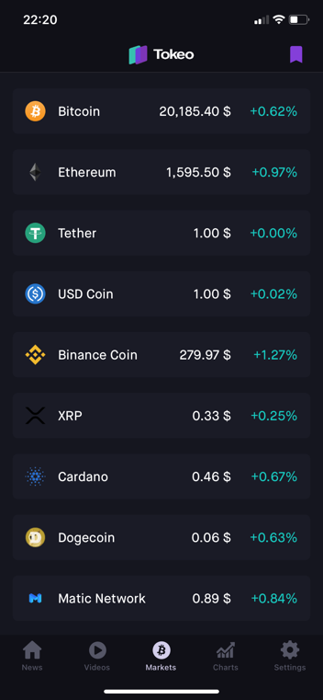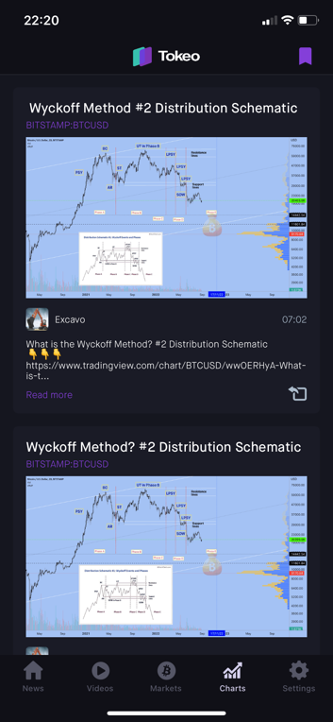

The stakeholders of the application are both beginners and professionals and just ordinary users who always want to know what is happening in the world of cryptocurrencies (this is an audience of just interested people, not beginners). I think that I found a way to adapt the mobile application to the needs of all categories of users: make one version of the application with a different set of features.

When I will be developing a mobile application such as this, it is important to focus on improving performance, speed of data transfer and updating, and rendering of diagrams. Mandatory is the optimization of the application to work on **both** the phone and the tablet (if time permits). At the expense of design, I think that there must be a dark theme that is gentle on the eyes in the dark, but it can be better to make a theme switcher (light and dark).

Professionals and beginners will have enough tools to keep up with the trends. Diagrams, indicators, special calculators, and converters, all this is very important, and I will try to foresee it all.